Swiggy Analysis Using MYSQL

1. How many restaurants have a rating greater than 4.4?

🡪 select * from swiggy where rating > 4.4;

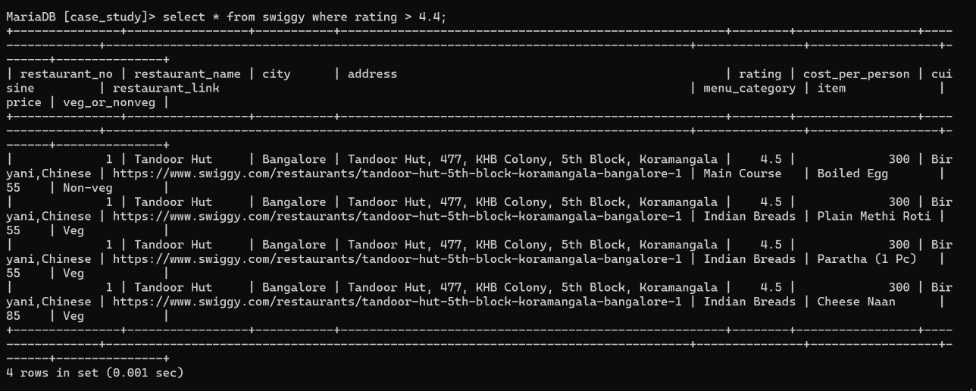

1. Which is the top city with have highest number of restaurants?

🡪select city, count(distinct restaurant_name) as highest_restaurant_count from swiggy

order by city desc;

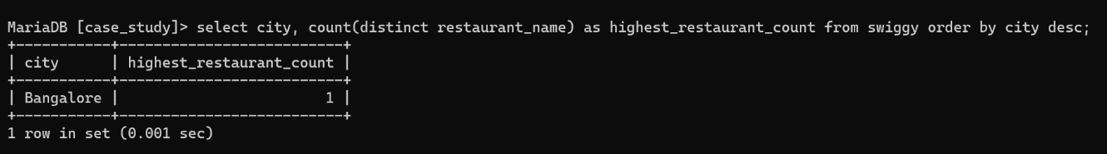

1. How many restaurants have the word “pizza” in their name?

🡪 select restaurant_name as pizza_restaurant from swiggy where restaurant_name like

"%pizza%";

4.What is the most common cuisine among the restaurant In the dataset?

🡪 select cuisine,count(*) as cuisine_count from swiggy group by cuisine order by

cuisine_count desc limit 1;

5.what is the average rating of restaurants in each city?

🡪 select city,avg(rating) as average_rating from swiggy group by city;

6.What is the highest price of item under the recommended menu category for each restaurant?

🡪 select distinct restaurant_name,menu_category,max(price) as highestprice from swiggy where menu_category='recommended' group by restaurant_name,menu_category;

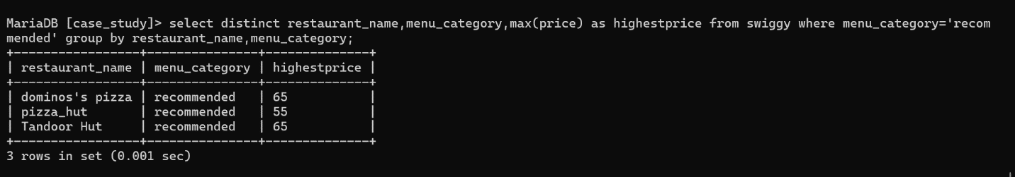

7.Find the restaurants that have an average cost which is higher than the total average cost of all restaurants together?

🡪select distinct restaurant_name,cost_per_person from swiggy where

cost_per_person>(select avg(cost_per_person) from swiggy);

8.Retrieve the Details of restaurants that have the same name but are located in different cities?

🡪select distinct t1.restaurant_name, t1.city, t2.city from swiggy t1 join swiggy t2 on t1.restaurant_name = t2.restaurant_name and t1.city<>t2.city;

9.Which restaurant offers the most number of items in the main course category?

🡪 select distinct t1.restaurant_name, t1.city, t2.city from swiggy t1 join swiggy t2 on t1.restaurant_name = t2.restaurant_name and t1.city<>t2.city;

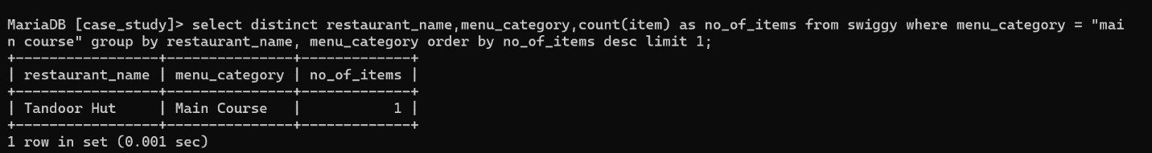

10.List the Names of restaurants that are 100% vegetarian in alphabetical order of restaurants name?

🡪 select distinct restaurant_name, (count(case when veg_or_nonveg='Veg' then 1 end)*100/ count(*)) as vegetarian_percetage from swiggy group by restaurant_name having vegetarian_percetage=100.00 order by restaurant_name;

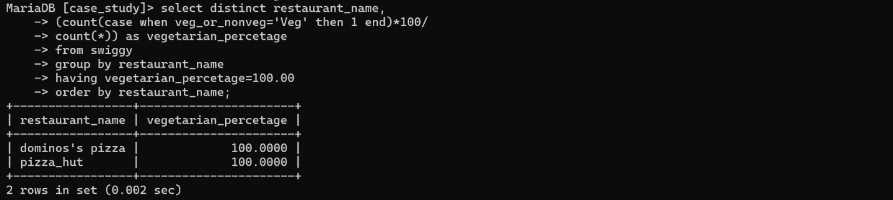

11.which is the restaurant providing the lowest average price for all items?

🡪 select distinct restaurant_name, avg(price) as average_price from swiggy group by

restaurant_name order by average_price limit 1;

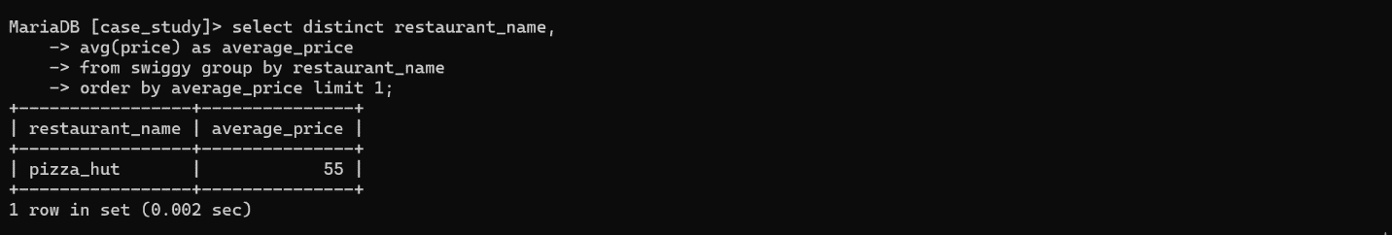

12.Which top 5 restaurant offers highest number of categories?

🡪 select distinct restaurant_name, count(distinct menu_category) as no_of_categories

from swiggy group by restaurant_name order by no_of_categories desc limit 5;

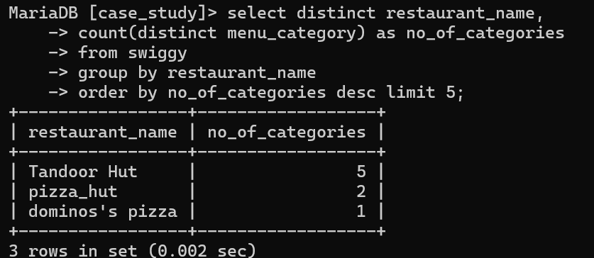

13. Which restaurant provides the highest percentage of non-vegetarian food?

🡪 select distinct restaurant_name, (count(case when veg_or_nonveg='Non-veg' then 1 end)*100 /count(*)) as nonvegetarian_percentage from swiggy group by restaurant_name order by nonvegetarian_percentage desc limit 1;

